Lecture-01, Differential Calculus and coordinate Geometry(Math-1), Sunday, January 30, 2022

Course Teacher: Prof. Dr. Kh. Abdul Maleque

Indices:

Logarithm:

Trigonometric function: Ratio between two sides of right-angled triangle is called trigonometric or circular function which is represented by sine, cosine or tangent.

Cartesian/rectangular form (

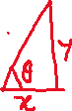

Polar form



Write the polar form of the point

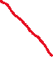

#Convert to rectangular coordinates

Cartesian form

#

Interval:

Marks distribution:

Quizes 40% (Best of two will be counted from three quizzes)

Written (MCQ 20 marks+Viva 20 marks) 40%

Attendance +Performance 10%

Assignment 10%

Total grand= 40% of Midterm +60% of Final term

Lecture-02, Differential Calculus and coordinate Geometry(Math-1), Tuesday 01/02/2022

Quadrant

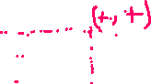

Function

Constant: Constant is a symbol which takes unchanged value

Constant is represented by

Variable: Variable is a symbol which takes changeable value

and is represented by

Two types of variable: (i) Dependent variable (ii) Independent variable

Let variable depends on the variable then we may write

Domain: exists for the value(s) of , set of the value of is called domain, domain is represented by

exists for

(i) Denominator not equal to zero

(ii) Inner of square root is not negative

(iii) Inner of logarithm is not negative and zero

Find the domain and the range of the following functions

Range: range

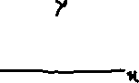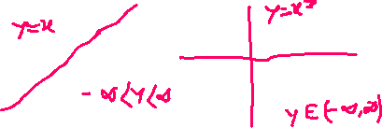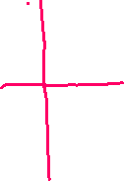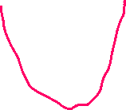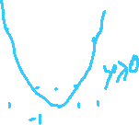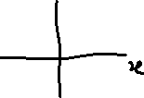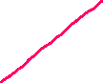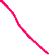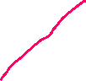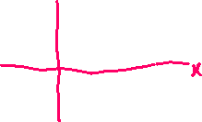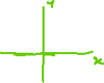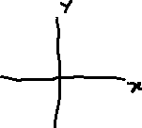

Lecture-03, Differential Calculus and coordinate Geometry(Math-1), Sunday 06/02/2022

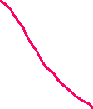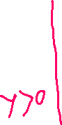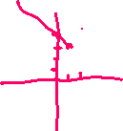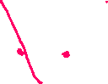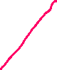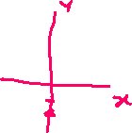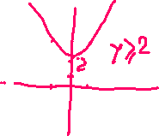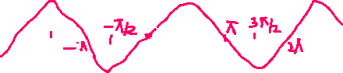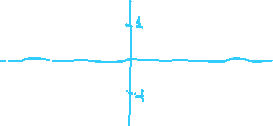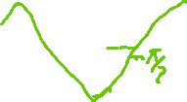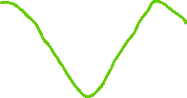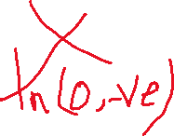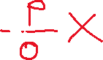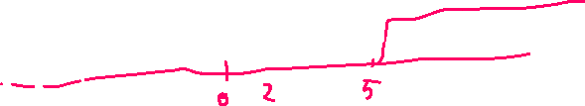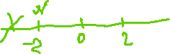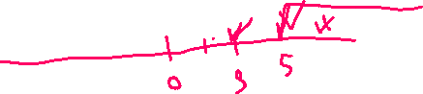

#

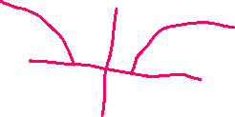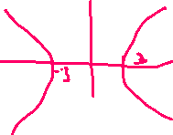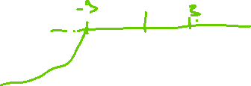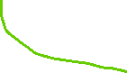

Limit:

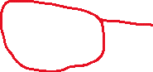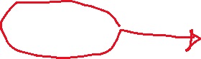

Exercises , ,

*L.Hospital rule:*

Lecture-04, Differential Calculus and coordinate Geometry(Math-1), Tuesday 08/02/2022

Ex11.

=

OR

Page-138

Continuity

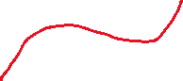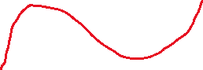

is continuous from A to B

is not continuous function from A to D

Def: is continuous function at if

is continuous function at if

Otherwise discontinuous function

is continuous or not at

does not exist. So f(x) is not continuous function at x=2.

at .

OR

OR

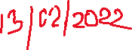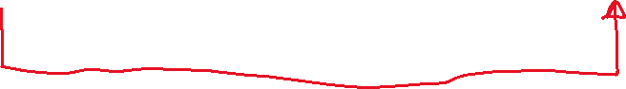

is continuous at x=2.

at .

is not continuous function at

Lecture-05(Makeup of Sunday), Differential Calculus and coordinate Geometry(Math-1), Thursday 10/02/2022

Differentiation:

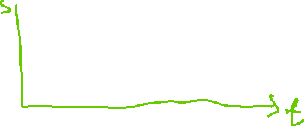

Change of time

Change of displacement

Rate of change is

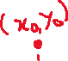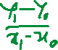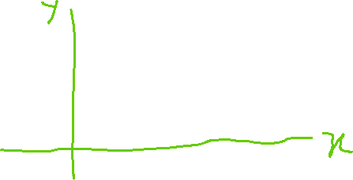

Is called First principle of differentiation

Find the differentiation of the following functios

By using 1st principle of differentiation, we have